## Working with Google Colab

Google Colab is an online editor where you can write, build, and run a Python notebook. For each assignment this semester, we’ll be using Colab to distribute programming sections. This document is meant to give you a basic familiarity with Colab’s interface and editor.

When we give you a Colab link for a programming assignment, you will likely only be able to view this version.

You can create a copy of the Colab by going to File -> Save a copy in Drive (Drive에 사본 저장)

This will create a copy locally in your Google Drive folder. For the duration of the assignment, this is the version of the Colab that you will be editing and opening.

You’ll likely find this file by going to <https://drive.google.com>. We recommend creating a folder for each of your assignments so all of your assignment materials are in the same place.

To view the file system available to Colab, click on the small Folder icon along the left edge of the screen:

For most assignments, we’ll need to download some datasets for you to work with on your local copy. You’ll hopefully see them here after you run the download script.

Colab has two types of cells: a text cell and a code cell. To run a code cell, you want to press the large play button on the left-hand side of the cell when you click into it:.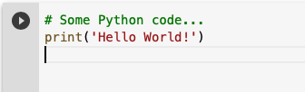

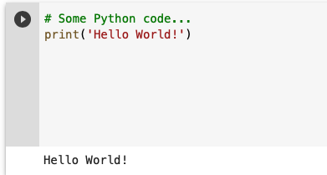

If there is any output, it will print out in a box right below the code cell.

Code cells are run one-by-one by default. Since most cells towards the bottom of the Colab rely on code in the cells above, make sure that you run the cells above if you have not already done so.

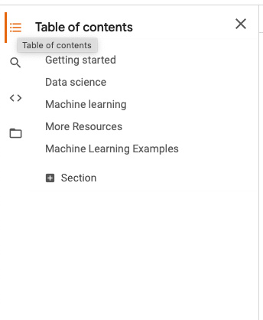

Most Colabs have some structure. To view an outline of the assignment, click on the ‘Table of Contents” icon on the left bar.

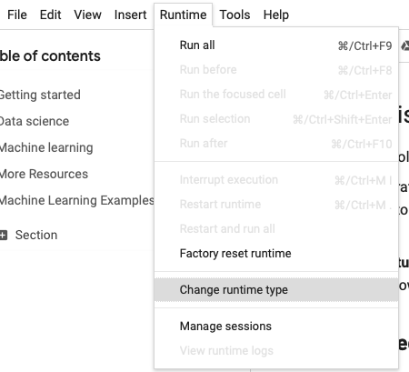

Google Colab also allows you to connect one GPU for free. You can add this to your runtime by going to “Runtime → Change runtime type → Hardware Accelerator → GPU → Save”.

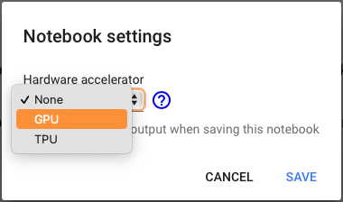

For some compute-intensive assignments, you should use this GPU accelerator to reduce the amount of time you’re waiting for results.

For more information about using Colab, check out the following tutorials:

* [Introduction to Google Colab](https://colab.research.google.com/notebooks/intro.ipynb)
* [Overview of Google Colab Features](https://colab.research.google.com/notebooks/basic_features_overview.ipynb)